

An Internship Report

ON

**Web Application on a Virtual Shopping Experience**

**Internship Report – Autumn 2020**

Submitted By

**Name: Ferdous Reza**

**ID: 1530194**

Spring-2021

Supervisor

**Mrs. Sabrina Alam**

Lecturer

Department of Computer Science and Engineering

**Independent University, Bangladesh**

Company Name: Unisoft Business Solutions Ltd.

Submission Date

9th June, 2021

Attestation



Signature______________

Name_________________

Date__________________

Acknowledgment

Firstly, I will give thanks to ALLAH for providing me the opportunity to work hard and stay strong.

Secondly, from the core of my heart I want to thank Mrs. Sabrina Alam, Lecturer, Department of Computer Science & Engineering, Independent University, Bangladesh, for helping me throughout this entire course. She was so helpful regarding all the things I needed during my internship. She guided me to complete this report.

Then I would like to express my gratitude to my external supervisor **Engr. Mohammad Afzal Hossain** (Managing Director & CEO) and **Rayhan Ahmmed**, (Manager, Business development), Unisoft Business Solutions Ltd., for his assistance and encouragement during the path of my internship. Also I would like to mention our Admin Rosie Akhter, for her amazing support and care. The blessing, help, and guidance that were given time to time shall carry me a long way in the journey of life on which I am about to embark.

I am very grateful to my office colleagues and peers for being so helpful. They have made my internship more enjoyable. Without them, it would be impossible to do this project.

Finally, I want to thank Independent University, Bangladesh (IUB) for giving me the opportunity to complete my internship. During this internship course it helped me explore many vital aspects of IT field. I have learned a lot during doing my project work.

Letter of Transmittal

9th June, 2021

Mrs. Sabrina Alam

Lecturer,

Department of Computer Science and Engineering,

Independent University, Bangladesh

Subject: Internship Report Submission, Autumn 2020

Dear Sir,

I, Ferdous Reza, ID:1530194, is submitting my internship report on online application of an e-commerce website which can be regarded as a virtual store. It has been 3 months program from 1st March 2021. I did my internship as a front-end web developer at Unisoft Business Solutions Ltd.

In this report, I added all of my best tried for data, operating and my capability with the end result of the work.

I am terribly grateful to you for your glorious guideline and support for doing this project. I will be significantly glad if you please kindly undergo this report and assess my works.

Sincerely yours,

Ferdous Reza

ID: 1530194

Evaluation Committee

. . . . . . . . . . . . . . . . . . . . . . . . . . . . . . . . . . . . . . . . . . . . . . . . . . . . . . . . . . . . . . . . . . . . . . Signature

. . . . . . . . . . . . . . . . . . . . . . . . . . . . . . . . . . . . . . . . . . . . . . . . . . . . . . . . . . . . . . . . . . . . . . Name

. . . . . . . . . . . . . . . . . . . . . . . . . . . . . . . . . . . . . . . . . . . . . . . . . . . . . . . . . . . . . . . . . . . . . . Supervisor

. . . . . . . . . . . . . . . . . . . . . . . . . . . . . . . . . . . . . . . . . . . . . . . . . . . . . . . . . . . . . . . . . . . . . . Signature

. . . . . . . . . . . . . . . . . . . . . . . . . . . . . . . . . . . . . . . . . . . . . . . . . . . . . . . . . . . . . . . . . . . . . . Name

. . . . . . . . . . . . . . . . . . . . . . . . . . . . . . . . . . . . . . . . . . . . . . . . . . . . . . . . . . . . . . . . . . . . . . Internal Examiner

. . . . . . . . . . . . . . . . . . . . . . . . . . . . . . . . . . . . . . . . . . . . . . . . . . . . . . . . . . . . . . . . . . . . . . Signature

. . . . . . . . . . . . . . . . . . . . . . . . . . . . . . . . . . . . . . . . . . . . . . . . . . . . . . . . . . . . . . . . . . . . . . Name

. . . . . . . . . . . . . . . . . . . . . . . . . . . . . . . . . . . . . . . . . . . . . . . . . . . . . . . . . . . . . . . . . . . . . . External Examiner

. . . . . . . . . . . . . . . . . . . . . . . . . . . . . . . . . . . . . . . . . . . . . . . . . . . . . . . . . . . . . . . . . . . . . . Signature

. . . . . . . . . . . . . . . . . . . . . . . . . . . . . . . . . . . . . . . . . . . . . . . . . . . . . . . . . . . . . . . . . . . . . . Name

. . . . . . . . . . . . . . . . . . . . . . . . . . . . . . . . . . . . . . . . . . . . . . . . . . . . . . . . . . . . . . . . . . . . . . Convener

Abstract

In this report I will be presenting all the information that I have gathered during my internship. This course “Internship” is offered by Independent University, Bangladesh (IUB). I joined Unisoft Business Solutions Ltd. for my internship. The company assigned me with tasks daily. They trained me to work on their systems.

This report describes the internship I spent at Unisoft Business Solutions Ltd. as a front-end Web Developer. In this report, I mainly have incorporated my experience at Unisoft Business Solutions Ltd. Especially the Ecommerce portal system I was working on where I also have provided details about my work experience as a web developer.

This report is about e-commerce portal system development. Detailed discussed given on this report.

The first chapter is the Introduction and the company profile where I describe my workplace and background as well as their missions and visions. Chapter 2 is about the experience and job responsibilities. Chapter 3 looks into the issues and challenges faced during the internship period. Chapter 4 talks about the project that I have done throughout my internship period. This chapter goes into all the details related to the project. Then, chapter 5 is the conclusion and implications. And lastly chapter 6 and 7 are References and the Appendix respectively.

**Table Of Contents**

**Table of Contents**

Attestation………………………………………………………………………………………………. ii

Acknowledgment…………………………………………………………………………………….. iii

Letter of Transmittal……………………………………………………………………………….. iv

Evaluation Committee……………………………………………………………………………… v

Abstract…………………………………………………………………………………………………… vi

1.0 Introduction………………………………………………………………………………………...13

1.1 Company profile……………………………….……………………………………….13

1.1.1 Vision, mission & objective….………………………………………..14

1.1.2 Corporate divisions……………………………………………………….15

1.1.3 Details of the product lines or services………………………….15

2.0 Internship experience & observation details……………………………………...19

2.1 Job responsibilities…………………………………………………………………...20

2.2 Literature Review……………………………………………………………………..20

3.0 Methodology……………………………………………………………………………………...22

3.1 Overview……………….………………………………………………………..23

3.2 Waterfall Model ……………………………………………………………..23

3.3 Waterfall Model Design.…………………………………………………. 24

3.4 Waterfall Model Advantages.…………………………………………..25

3.5 Waterfall Model Disadvantages….…………………………………...26

3.6 Developer Tools…………………….………………………………………...27

4.0 Project Management…………………………………………………………………………...33

4.1Work Breakdown Structure………………………………….…………...34

Chapter 5: Body of Project………………………………………………………………………….35

5.1 Description of the project…………………………………...…………...36

5.2 Web Page Details.……………………………………………………………..36

5.3 System Analysis………………………………………………………………...37

5.4 Six Element Analysis………………………………………………………….37

5.5 Feasibility Analysis…………………………………………………………… 39

5.6 System Design……………………………………………………….………… 40

5.7 Use Case Diagram………………………………………………………………40

5.8 Activity Diagram………………………………………………………………...41

5.9 Non-Functional Requirement……………………………………………..42

5.10 Functional Requirement……………………………………………………42

6.0 Result…………………………………………………………………………………………………….48

6.1 Home Page……………………………………………………………………………….49

6.2 Shop Page………………………………………………………………………………...50

6.3 Sign-in And Sign-up page…………………………………………………………..51

6.4 Checkout page…………………………………………………………………………..53

6.5 Payment…….……………………………………………………………………………..55

7.0 Internship outcome & issue analysis……………………………………………………...57

7.1 Problems & challenges faced in the workplace…………………………….58

8.0 Conclusion………………………………………………………………………….………………….60

8.1 Future work…………………………………………………………………...………………...60

8.2 References………………………………………………………………………………………..61

8.3 Appendix…………………………………………………………………………………………..62

**List Of Figures**

|  |  |  |
| --- | --- | --- |
| Figure No. | Name | Page No. |
| 3.1 | Waterfall Model | 24 |
| 3.2 | React | 27 |
| 3.3 | Firebase | 29 |
| 3.4 | Firebase working flow | 30 |
| 3.5 | Git | 30 |
| 3.6 | GitHub | 31 |
| 3.7 | Heroku | 32 |
| 4.1 | Work Breakdown Structure | 34 |
| 5.2 | Use Case Diagram | 40 |
| 5.3 | Activity Diagram | 41 |
| 6.1 | Home Page | 49 |
| 6.2 | Shop Page | 50 |
| 6.3 | Sign In/ Sign Up | 51 |
| 6.4 | Sign In with google | 52 |
| 6.5 | Checkout page button | 53 |
| 6.6 | Checkout Page | 54 |
| 6.7 | Payment Option | 55 |
| 6.8 | Payment with card | 56 |
| 6.9 | Payment Complete | 56 |
|  |  |  |

**List of Table**

|  |  |  |
| --- | --- | --- |
| Table No. | Table Name | Page |
| 5.1 | Six Elements Analysis | 37 |
| 5.4 | Consistency | 43 |
| 5.5 | Sign In for Admin | 43 |
| 5.6 | Registration for Admin | 44 |
| 5.7 | Sign In for User | 44 |
| 5.8 | Administration Page Activities | 45 |
| 5.9 | Homepage Activities | 45 |
| 5.10 | Shop Page Activities | 46 |
| 5.11 | Cart Page Activities | 46 |
| 5.12 | Category Page Activities | 47 |

**Chapter: 1.0 Introduction**

**1.0 Introduction**

Internship provides a student with an opportunity to relate their theoretical knowledge with the complex real-world environments. Moreover, if the internship is within a bachelor program and the students have to return to the academy after completing it, the skills that they have developed during the internship help them to gain a sounder academic result.

Independent University, Bangladesh (IUB) provides that glorious opportunity to their students of having an internship within their bachelor program. I started my internship as a React front-end Developer intern in 1st March, 2021. The expectations were high and now almost nearing the end of my internship, I must admit that it was really a wonderful experience despite the pandemic

The journey was not that simple. There were many obstacles, with the on going pandemic and the governmental restrictions as well as the new technologies that I have to handle with. But yet, after overcoming each challenge, I discovered a new potential within myself. The skills that I have gathered are priceless to me. In addition to that, some of the non-technical skills that I have procured, combined with those technical skills will certainly prove worth in my career.

**1.1 Company profile**

Unisoft Business Solutions Limited (UBSL) is an emerging software Company in Bangladesh producing world-class quality software for its clients since 2010. We produce intelligent and powerful software which completely maneuvers our client’s job competently. We are committed to continuous advancement in our intellect and expertise and thus accomplishing our success through the pursuit of elevated performance and quality. We believe that our job is to listen, research and understand the requirements unique to each individual business. In fact, it is the long-term relationships with our clients that has served as a solid foundation for our company. For companies operating in the information age we help to leverage new technologies to competitive advantage. We deliver high value innovated solutions by bridging the gap between business and technology. Since UBSL’s inception, proven, demonstrate and invent unique products, techniques and capabilities that far and uniquely distinguish us from other software provider as we are specialized in developing varies automated solutions in the field of Manufacturing Company, Garments, Textile, Knitwear, Knitting, Dyeing, Washing, Spinning and Others Small and Mid-level Organization, that is tailored to utilize the International Standard.

**1.1.1 Vision, Mission & Objective**

**Mission**

Their mission is to emerge as a leader in the bangladesh information technology industry – through total customer satisfaction and employee motivation.

**Vision**

To build a global service delivery company through transformation of human resource and skill with management expertise. Become a well recognized technological firm in the technological sector.

**Objective**

To provide efficient and cost-effective solutions to complex information management requirements through innovative application of the latest in technology.To provide an informal yet highly professional environment to our workforce and nurture them towards identifying the organization’s goals as their personal targets.To achieve excellence in every sphere of operation.

**1.1.2 Corporate divisions**

Our office is situated in Uttara, Sector-11. This is the only branch of our company. The company is still in their early stages and does plan to expand.

**1.1.3 Details of the product lines or services**

Our software team is specialized in producing software to assist you to operate your entire industry smoothly. Our development team consists of experienced and qualified system analysts, application developers, solution developers, database administrators, programmers and testers. Almost all of them are certified professionals in their respected areas including OCP, MCAD, CCNA etc. In each step of development, we use creative ideas, cutting-edge technologies and proven methodologies. It is rest assured that the software will be top-rated and most user-friendly.

**What We Do:**

1.Software Development

2.Technology Consultancy

3.Web Application Development

4.Prototyping and R&D

5.Mobile App Development

6.Product maintenance

7.Database Design & Data Migration

**Services**

UBSL is a competent provider of any kind of software solutions including mission critical business applications, complex engineering of software, data centric analytical software, smart device solutions, web solutions and so on. Our expertise lies in clearly perceiving the business goals of our customers, choosing the most appropriate technologies and efficiently developing solutions catered to the business needs.

Software Development:

Unisoft is an experienced software development firm providing software development services. Our cost-effective solutions are built specifically for organizations by utilizing an intimate understanding of their business and industry landscape. We offer rich, user friendly and robust applications in combination with any modern database system. The application can be totally standalone running in a single machine, network solutions or internet connected application.

Services include: Enterprise Application, Desktop Application, Web Application, Mobile and Tablet Apps, Software Maintenance and Software Re-Engineering.

Database Development:

We offer different types of database development services from design to reporting. Unisoft is experienced in standard database technologies like Oracle, Microsoft SQL Server, MySQL, PostgreSQL and different Big Data and Cloud database systems. We maintain best practices in planning, development, maintenance and security including ongoing monitoring and automation when need. Services are:

Services include: Database Design, Database Migration, Database Integration, Database Performance Tuning, DB Analysis & reporting Data Security.

Mobile App Development

Our team of experienced mobile apps developers and designers can build an app that will live up to your vision enabling you to leverage mobility to maximize productivity. Unisoft is developing business critical solutions for mobile devices for Android, iPhone giving you and your team more flexibility when you are moving.

Platforms: Android and iOS.

**Chapter 2.0 Internship experience & observation details**

**2.0 Internship experience & observation details**

As a student of Computer Science (CSE) everyone has to conduct a practical orientation in any organization for fulfilling the requirements of the 12 weeks Internship Program. The main purpose of the program is to expose the students to the real-world situation. Practical knowledge is fundamental for the application of theoretical intelligence. Bearing this in mind and internship program was being included in the CSE curriculum. The goal of this analysis is to expose the student in the organizational work situation and also to provide an opportunity for applying classroom learning in practice.

I started my internship from 1st of March 2021. I used to commute from my home in Siddheswari to Uttara every work day. It used to start from 9 am and ended on 6 pm. It took me awhile to get to know my colleagues and team members but we all got along well. There were four other interns with different experiences in this field. We were supervised by Rosie Akhter, our Admin. We always coordinated with our Admin in order collaborate with others. She also helped us a lot in our everyday interactions.

We, group of interns, always discussed our tasks and problems. My first month mostly consisted of revisions of my previous knowledge as well as learn and train in React language and framework.

My second month started with working from home due to governmental restrictions coming into place due to the pandemic. We started reporting at 9 am through Whatsapp group chats. During our office hours we always stayed connected through Skype calls. We were asked about our progress and was always encouraged to ask for support if any confusions arises. Then came the month of Ramadan and our timing changed from 12am to 6pm. This was only done for the interns for only the month of Ramadan. After Ramadan, our timing got back its usual 9am to 6 pm.

**2.1 Job Responsibilities**

From the first day, I was instructed to revise on my previous knowledge and start getting used to their preferred language, Reactjs. They suggested me to follow a few tutorials online and always would suggest to discuss problems faced and try to find the solution together. This was the learning phase of the internship. During this period we were monitored my our Admin. The next month, we moved to home office and were advised to stay connected through Whatsapp throughout the official hours. We were advised to start working on a project of our choice but has to be implemented using their preferred language.

We were also kept up to date with the on going projects that are going on in the company by just being present in their meeting. The idea was to get familiar with their traditional way of working. Our meetings were always held on Skype.

**2.2 Literature Review**

**Relationship with Undergraduate Studies:**

During our undergraduate studies, we have gone through many courses while doing majors and minors and I believe every single courses have helped me to complete my project at my company. However, I can not mention all the courses but I will name a few that has helped me substantially.

1. Introduction to Computer Programming (CSE 101): It is a foundation course that is meant to introduce us to the world of programming at the start of University. It was a very basic course that taught us how a computer “thinks” and “decides” to take an “action”. We learn this by learning to program in C++. Even though its a very basic high level language, I believe it helped a lot when learning other new languages.

2. Algorithms (CSE211): This is a major course that teaches the value of an algorithm used in a particular program. It taught us how programming in different ways can affect time and space in terms of computing. The knowledge learned in this course helped me choosing which algorithm would be most efficient for my project in hand.

3. Systems Analysis and Design (CSE307): This is also a major course that tries to explore the tools and techniques in order to design a digital system. It introduces us to all the different methodologies used to manage and build a project with the help of Systems development life cycle, UML diagrams, use case modeling etc.

4.Web Applications and Internet (CSE309): This is the course that has helped the most during my internship as my designation was as a Front-end developer. I learned a new programming language called Reactjs. It is very important to know and understand the workings of a basic website before moving on to learn Reactjs. This course has taught me HTML, CSS, javascript and php, here, the first three is considered to be a prerequisite when learning to work with Reactjs.

**Chapter 3.0: Methodology**

**3.1 Overview**

In this section, we will describe the methodology of our website. Here we are going to follow some new and easy process. There are many ways to develop methodology or system methodology that is needed for developing and maintaining a project. There are many methodologies for doing a project. They are:

* Prototype Methodology
* Waterfall Model
* Agile
* Scrum

Here, I chose the waterfall model

**3.2 Waterfall Model**

The Waterfall Model was the first Process Model to be introduced. In a waterfall model, each phase must be completed before the next phase can begin and there is no overlapping in the phases.  
This means that any phase in the development process begins only if the previous phase is complete.

**3.3 Waterfall Model -Design**

In the Waterfall Model approach the whole process of software development is divided into separate phases. In this model typically the outcome of one phase acts as the input of next phase sequentially.

Figure3.1: Waterfall Model

The sequential phases in waterfall model are: -

* **Requirement Gathering and analysis:** all possible requirement of the system to be developed are captured in this phase and documented.
* **System Design:** in this phase the system is prepared to design based on the requirement specifications.
* **Implementation:** in this phase system is developed based on its design.
* **Testing:** in this phase the entire system is tested for any faults and failures.
* **Deployment:** oncethe functional and non-functional testing is done then the product is deployed to the customer.
* **Maintenance:** there are some issues which come up from the client after system released. In this phase is to fix those issues and enhance the product for better versions.

**3.4 Waterfall Model Advantages**

The advantages of waterfall development are that it allows for departmentalization and control. Development moves from concept, through design, implementation, testing, installation, troubleshooting, and ends up at operation and maintenance.

Some of the major advantages -

* It is simple and easy to understand and use
* Clearly defined stages
* Easy to arrange tasks

**3.5 Waterfall Model Disadvantages**

Disadvantage of waterfall development is that it does not allow much reflection or revision. Once an application is in the testing stage, it is very difficult to go back and change something.

Some of the major disadvantages –

* No working software is produced until late during the life cycle.
* High amounts of risk and uncertainty.
* Not a good model for complex and object-oriented projects.
* It’s difficult to measure progress within stages.
* Cannot accommodate changing requirements.

**3.6 Development Tools used**

For e-commerce website ‘’Virtual Shop Ltd’’ we used several modern development tools.

React:-



Figure3.2: React Logo

In a small definition react is a declarative, efficient and flexible JavaScript library for building user interfaces. It is created by Facebook.

It is currently one of the most popular JavaScript front-end libraries which has a strong foundation and a large community supporting it.

React can be used as a base in the development of single page applications or mobile applications. Complex react applications usually require the use of additional libraries for state management (redux), routing and interaction with an API.

As we all know many JavaScript frameworks like angular, backbone, ember and more and more were already in the industry to manage our applications but we used React-Js because it is: -

* Simple: beauty of react is its simplicity. It is a component-based language with a well-defined lifecycle. In react development developers use JSX which allows you to mix HTML with JavaScript. This is not a requirement and developers can write in plain JavaScript but JSX is much easier to use.
* Easy to learn: if anyone has knowledge in programming the they can easily understand react but angular and ember are referred to as domain-specific-language which makes them difficult to learn. For react you just need basic knowledge of CSS and HTML.
* Native approach: react can be used to create mobile applications with “react native”.

The main point about react it is a component-based language and everything here is a component. If you make any UI it can work as a component for others.

Redux: Redux is an open-source JavaScript library for managing application state. It is most commonly used with libraries such as React or Angular for building user interfaces. Similar to Facebook's Flux architecture, it was created by Dan Abramov and Andrew Clark.

Firebase: -



Figure3.3: Firebase

Firebase is an open-source tool set to build, improve and grow your app and the tools is gives you can cover a large portion of your applications it is back-end. This includes things like analytic, authentication, databases, configuration, file storage, push messaging and more. This is different than traditional app development which is typically involves writing both front-end and back-end. However, with firebase the traditional back-end is bypassed. And administrative can access firebase as an online dashboard.

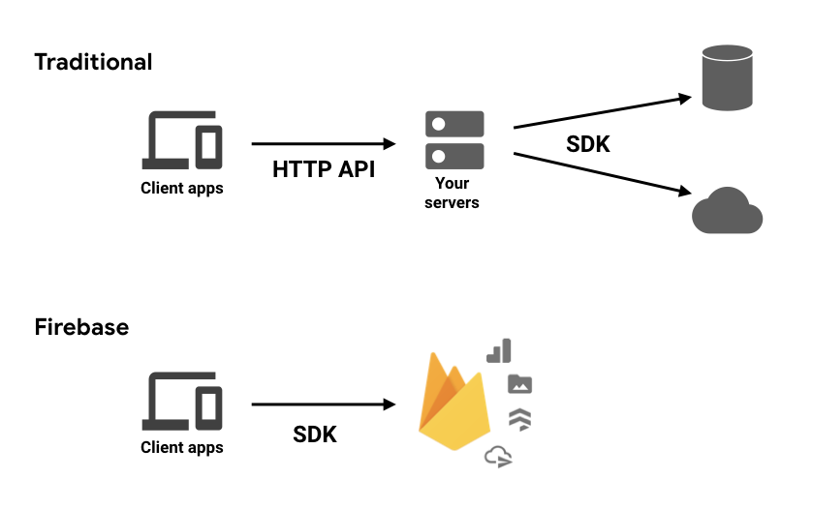

Figure3.4: Firebase working flow

Git: -

Git is a free open-source distributed version control system. It is used for tracking change in source code during software development. It is designed for coordinating work among programmers, but it can be used to track changes in any set of files. Its goals include speed, day integrity and support for distributed non-linear workflows. Version Control is a system that records changes to a file or set of files, over time so that specific version can be recalled later.

Figure3.5: git

GitHub: -



Figure3.6: Github

GitHub is a community where more than 56 million people learn, share and work together to build software.

Heroku: -

Heroku is a container-base cloud Platform as a Service (PaaS). Developers use Heroku to deploy, manage and scale modern apps. It is elegant, flexible and easy to use.



Figure3.7: heroku

**Chapter 4.0: Project Management**

**4.1 Work Breakdown Structure**

Dividing complex and large projects in simple and easy form is defined as work breakdown structure (WBS). Work breakdown structure is a hierarchical tree structure that breaks a project into smaller portions. In my project I use the top-down approach to describing the whole process.

Virtual Store

Initiation

Implementation

Requirement

Design

Testing

Deployment

Project Background

According to requirement start coding

Unit test

Collecting requirement

Project Objectives

UI design

System testing and review

Final project deployment

Planning for projects

Functional requirement

Non-Functional requirement

Review

Fix bugs

User acceptance test

Connect to database

approval

Figure:4.1- Work Breakdown Structure

**Chapter 5.0: Body of Project**

**5.1 Description of the project**

My project name is “Virtual Store Ltd” which is an online shopping website. In this virtual store anyone can browse the catalog and buy products of interest.

Conditions:

* Any user can register, sign-in and view available products.
* User also can sign-in with google account.
* Only registered-user can purchase multiple products regardless of quantity.
* Contact page is available to contact admin for queries.
* There are three roles available: - visitor, user and admin.
* Visitor can view and con not purchase products
* Registered-user can view and purchase
* An admin has some extra privilege including all privilege of visitor and user.
* Admin can add products, remove and edit products.
* Admin can add/remove and edit user.

**5.2 Web Page Details**

* Homepage
* Shop page
* Category page
* Cart page
* Sign-in and Sign-up page
* Admin page

**5.3 System Analysis**

System analysis is a process of studying and observing a system to know how it works and identifying the problems and decomposition of a system into its components.

System analysis is conducted for the purpose of studying a system or its parts in order to identify its objectives. It is a problem-solving technique that improves the system and ensures that all the components of the system work efficiently to accomplish their purpose. What system should do system analysis specifies it.

**5.4 Six Element Analysis**

|  |  |  |  |  |  |  |
| --- | --- | --- | --- | --- | --- | --- |
| Process | System Roles | | | | | |
| Human | Non computing  hardware | computing  hardware | Software | Database | Communication and network |
| View homepage | Visitor/User/admin | N/A | Pc/Mobile | Windows 10/ any version of android or iOS | Firebase | Internet |
| View category page | Visitor/User/admin | N/A | Pc/Mobile | Windows 10/ any version of android or iOS | Firebase | Internet |
| View shop page | Visitor/User/admin | N/A | Pc/Mobile | Windows 10/ any version of android/iOS | Firebase | Internet |
| Sign-in and Sign-up page | Visitor/User/admin | N/A | Pc/Mobile | Windows 10/ any version of android or iOS | Firebase | Internet |
| View cart dropdown option | Visitor/User/admin | N/A | Pc/Mobile | Windows 10/ any version of android or iOS | Firebase | Internet |
| Cart page | Visitor/User/admin | N/A | Pc/Mobile | Windows 10/ any version of android or iOS | Firebase | Internet |
| Admin page | Admin | N/A | Pc/Mobile | Windows 10/ any version of android or iOS | Firebase | Internet |
| Contact page | Visitor/User/admin | N/A | Pc/Mobile | Windows 10/ any version of android or iOS | Firebase | Internet |
| Payment | User/admin | N/A | Pc/Mobile | Windows 10/ any version of android or iOS | Firebase | Internet |

Table5.1: six element analysis

**5.5 Feasibility Analysis**

On the off chance that the proposal is satisfactory to the administration then the next step is to apply the practicability study. This is a system to test the work is workable or not. These are categorized in many parts like technical, operational, social, economic, time consumption, etc. it helps to know the opportunity of this work. In practicability study will also show us about the cost as well as the benefits of which we are going to invest here.

Types of feasibility study:

1. Technical Feasibility: Technical feasibility focuses on the technical resources available to the project development. It helps the developers determine whether the technical resources meet capacity and whether the technical team is capable of converting the ideas into working systems. It also involves the evaluation of the hardware, software and other technical requirements of the proposed system. In my project I used very popular technologies like React-Js, Firebase for database. So, this project is technically practicable.
2. Operational Feasibility: The software must be user-friendly and operationally feasible by means that the software must work by each functionality given with no difficulties. This project “Virtual Shop Ltd.” is user-friendly and easy to use. So, “Virtual Shop Ltd.” can be determined as operationally feasible.
3. Economic Feasibility: As we all know no one can live their life without money so the economy is the most important part. Nowadays E-Commerce site is popular to everyone. So that it can be beneficial both for company and the client. So, “Virtual Shop Ltd.” is Economically Feasible.

**5.6 System Design**

It is a process of planning a new business system or replacing an existing system by defining its components or modules to satisfy the specific requirements.

Nowadays E-Commerce is very profitable business paradigm. It is reasonable and become common place for shopping.

“Virtual Shop Ltd” is an online shopping website. In this store user can choose their desire product and add to cart. User can register and also can sign-in with google. In the cart user can increase the quantity. For payment user pay bills via credit card.

**5.7 Use Case Diagram**

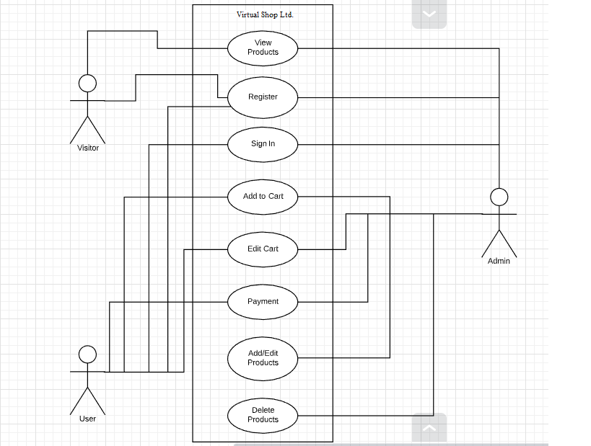

Figure 5.2: use case diagram

**5.8 Activity Diagram**

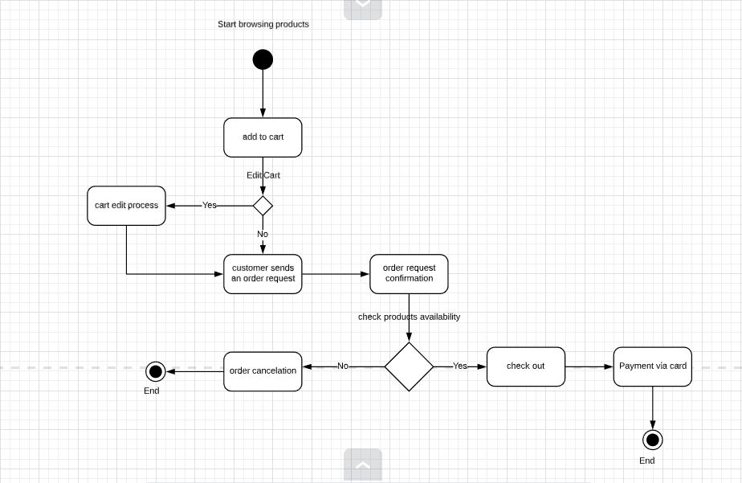

Figure5.3: activity diagram

**5.9 Non-Functional Requirements**

Security

* Page of the website must be access in the way they were intendent to be accessed. Included files shall not be accessed outside of their parent file.
* Administrator can only perform administrative task on the pages they privileged to access. Customers will not be allowed to access the administrator pages.

Efficiency and Maintainability

* Page loads should be returned and formatted in a timely fashion depending on the request being made.
* Administrators will have the ability to edit the aspects of the order forms, product descriptions, prices and website directly.

**5.10 Functional Requirements**

The functional requirement is that it essentially specifies something a system should do. The Functional Requirements are the operations and activities that a system must be able to perform. In our project. In this section we try to find functional requirements for User Interface/Admin. The following functional requirements were gathered and their inputs, behavior and output are discussed below.

|  |  |  |
| --- | --- | --- |
| Function Name: Consistent with all devices | | |
| Input:  N/A | Process:  website must be created in React Development Environment. | Output:  This website will accessible in every device. |
| Pre-Condition: User must have a smart device with net connection. | | |
| Post Condition: Anyone who can use a smart device also can use this website easily. | | |
| Alternative Option: N/A | | |

Table5.4: Consistency

|  |  |  |
| --- | --- | --- |
| Function Name: Sign-in for Admin | | |
| Input:  Email & Password | Process:  Admin Sign-in interface in the website | Output:  Administration interface in the website. |
| Pre-Condition: Must have internet connection and devices like Computer or smart phone. | | |
| Post Condition: Admin can login and can maintain & observe activities | | |
| Alternative Option: If email or Password are not valid then showing the alert. | | |

Table5.5: Sign-in for Admin

|  |  |  |
| --- | --- | --- |
| Function Name: Registration for User | | |
| Input:  DisplayName  Email, Password, Confirm Password | Process:  Website Register Interface | Output:  View Home Page or Cart Page in the website. |
| Pre-Condition: Must have internet connection and devices like Computer or smart phone. | | |
| Post Condition: Admin can add and remove the user information’s | | |
| Alternative Option: N/A | | |

Table5.6: Registration for User

|  |  |  |
| --- | --- | --- |
| Function Name: Sign-in for User | | |
| Input:  Email & Password | Process:  Website Sign-in Interface | Output:  View Home Page or Cart Page in the website. |
| Pre-Condition: Must have internet connection and devices like Computer or smart phone. | | |
| Post Condition: Admin can login and can maintain & observe activities | | |
| Alternative Option: If email or Password are not valid then showing the alert. | | |

Table5.7: Sign-in for User

|  |  |  |
| --- | --- | --- |
| Function Name: Administration Page Activities | | |
| Input:  N/A | Process:  Admin can add, edit and delete the data | Output:  Administration  Interface admin Page |
| Pre-Condition: Must have internet connection and devices like Computer or smart phone. | | |
| Post Condition: Admin can maintain & observe activities | | |
| Alternative Option: N/A | | |

Table5.8: Administration Page Activities

|  |  |  |
| --- | --- | --- |
| Function Name: Home Page Activities | | |
| Input:  N/A | Process:  Can view the category of products | Output:  View Home Page |
| Pre-Condition: Must have internet connection and devices like Computer or smart phone. | | |
| Post Condition: N/A | | |
| Alternative Option: N/A | | |

Table5.9: Home Page Activities

|  |  |  |
| --- | --- | --- |
| Function Name: Shop Page Activities | | |
| Input:  N/A | Process:  Can view the preview of all products | Output:  Shop preview page |
| Pre-Condition: Must have internet connection and devices like Computer or smart phone. | | |
| Post Condition: N/A | | |
| Alternative Option: N/A | | |

Table5.10: Shop Page Activities

|  |  |  |
| --- | --- | --- |
| Function Name: Cart Page Activities | | |
| Input:  N/A | Process:  Can view the order details of products, also remove product from cart and add | Output:  Cart Page |
| Pre-Condition: Must have internet connection and devices like Computer or smart phone. | | |
| Post Condition: N/A | | |
| Alternative Option: N/A | | |

Table5.11: Cart Page Activities

|  |  |  |
| --- | --- | --- |
| Function Name: Category Page Activities | | |
| Input:  N/A | Process:  Can view the overview of individual category | Output:  category overview page |
| Pre-Condition: Must have internet connection and devices like Computer or smart phone. | | |
| Post Condition: N/A | | |
| Alternative Option: N/A | | |

Table5.12: Category Page Activities

**Chapter 6: Results**

**6.0 Results**

Anyone can view this Online Shopping portal and available products, but every user must sign-in by his/her Email and password in order to purchase or order products. Unregistered members can register by navigating to registration page. Only Admin will have access to modify roles, by default developer can only be an ‘Admin’.

**6.1 Home Page**

In the home page where user find their favorite products. It has category menus and header navigation.



Figure6.1: home page

**6.2 Shop Page**

This is a preview page. This page shows all the available products for preview.



Figure6.2: shop page

**6.3 Sign-in And Sign-up page**

This is the sign-in and sign-up page. User can sign-in with email and password or sign-in with google account for quick access. The authentications part covered with firebase. User can sign-up and it connected with cloud storage provided by firebase. User information will save in firebase database both for authentication and sign-up.

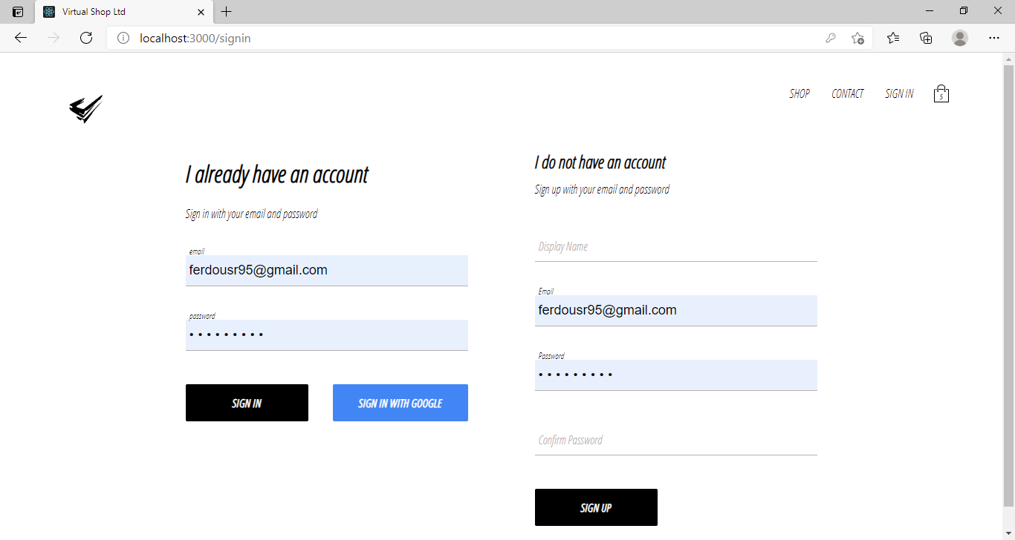

Figure6.3: sign-in and sign-up page

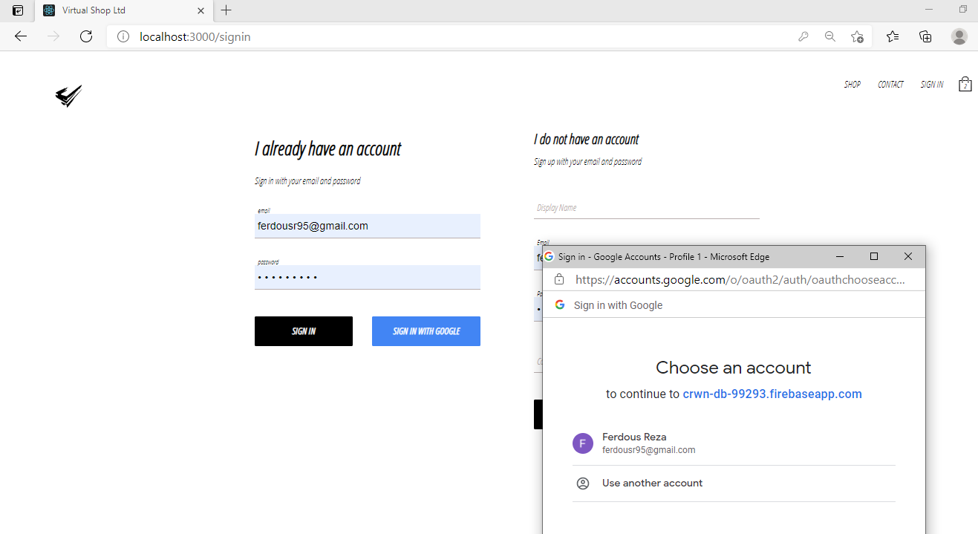figure6.4: Sign in with google account

**6.4 Checkout page**

After adding product to cart visitors and registered users can view cart page and the total amount and total quantity, after then only registered users can purchase their desired products. If visitors want to order, it required sign-in/register.

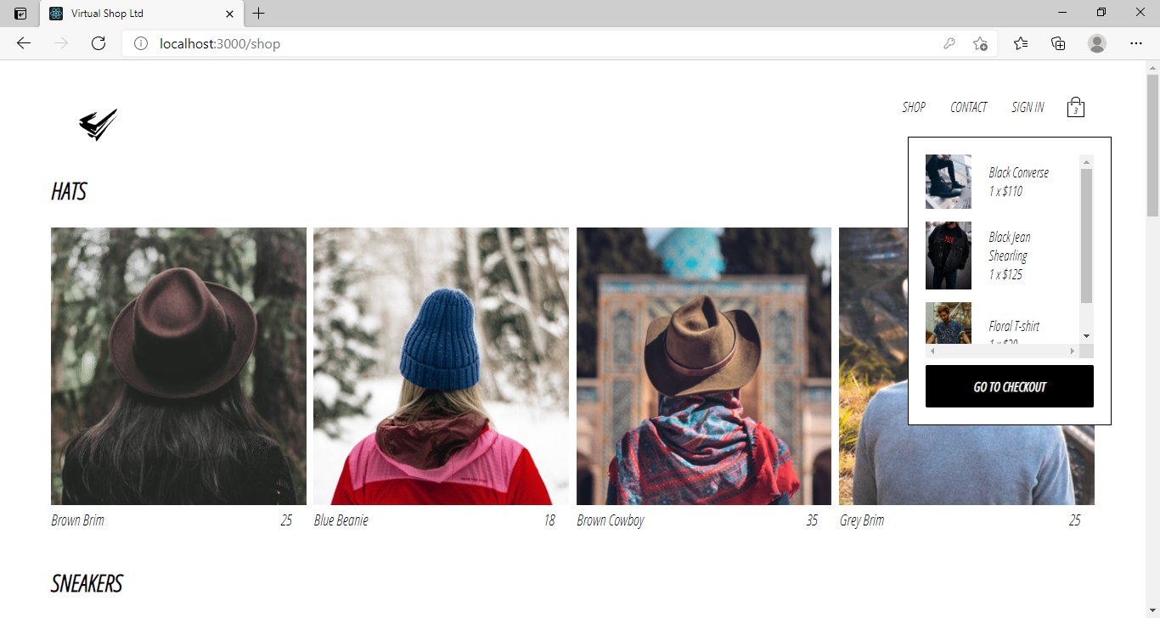Figure6.5: checkout page button from cart

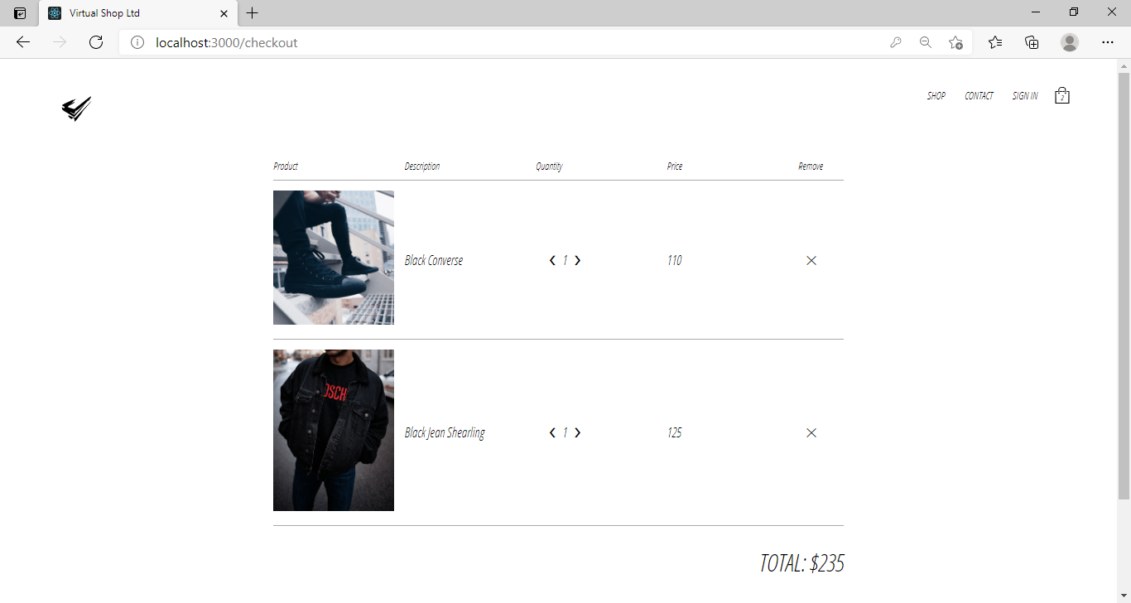Figure6.6: Checkout Page

**6.5 Payment**

This is the payment method: it accepts card for payment.

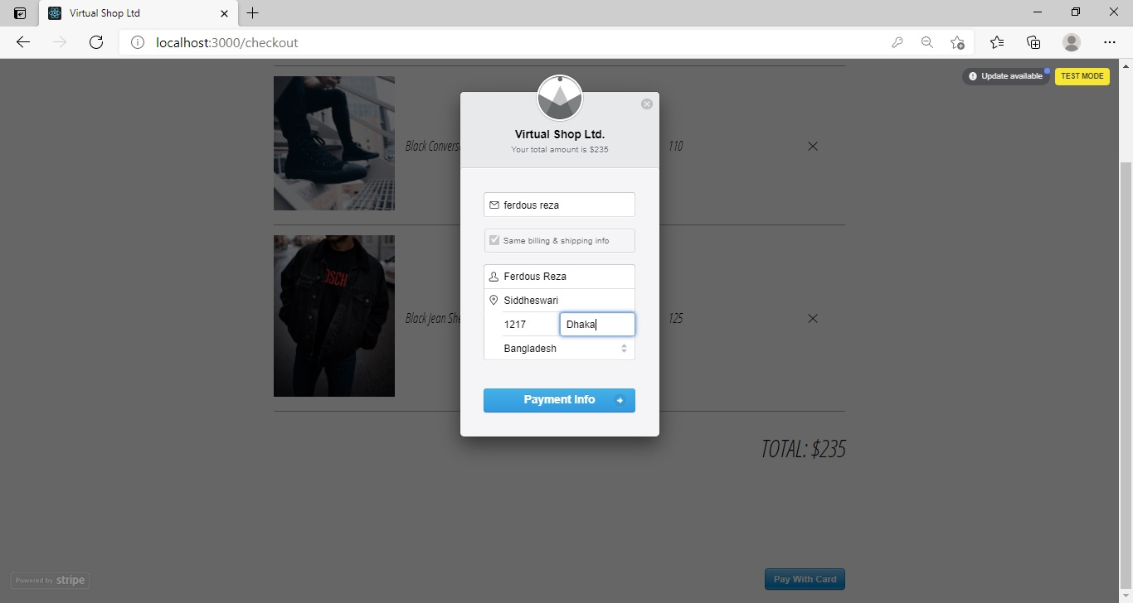Figure6.7: payment option

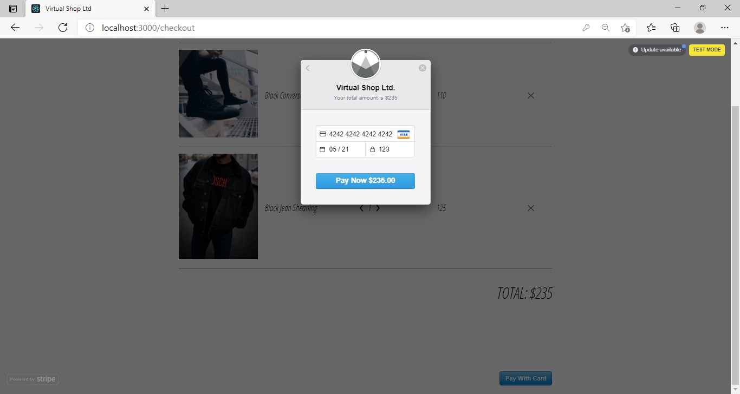 Figure6.8- Payment with card

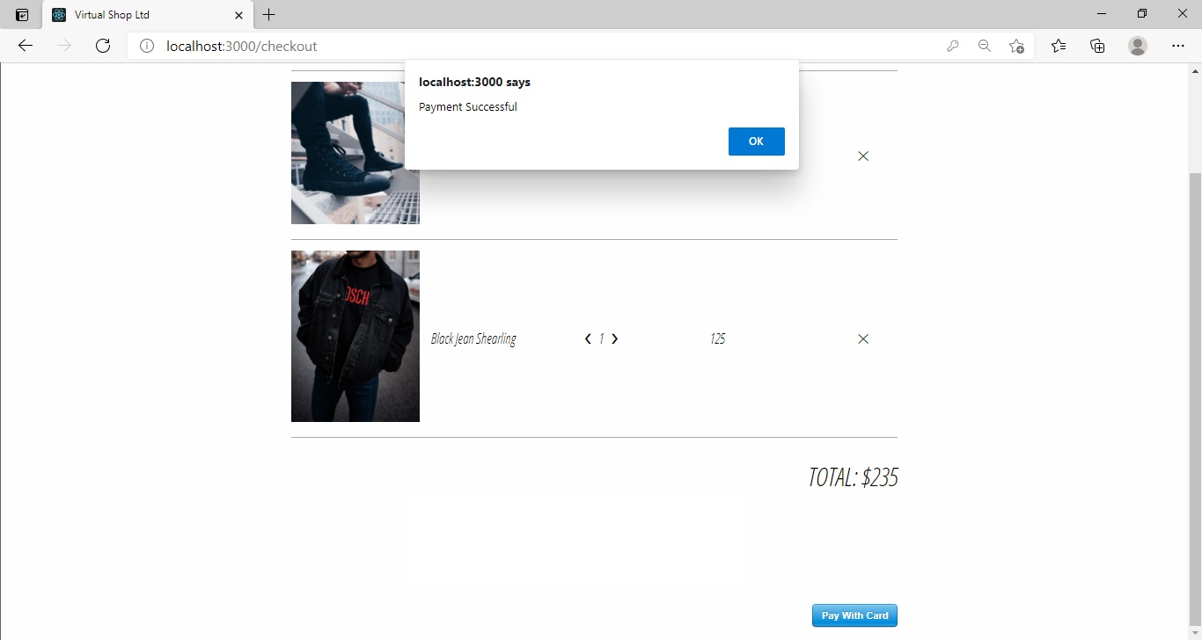 Figure6.9- Payment complete

**7.0 Internship outcome & issue analysis**

**7.1 Problems & challenges faced in the workplace**

I have only been to my physical workplace for the first month and that was too was very introductory and a learning phase. I did not face any problems there as everybody was very helpful and friendly..  
But there were some distractions due to the pandemic situation. Moreover, the governmental restrictions forced our company to start working from home. This had both positive and negative impact. The positive being that, I did not have to commute to work anymore. I could save a lot of hours just by not going to the physical workplace. But also not going to the workplace, we missed out a lot of the usual official interactions that used to take place on a daily basis. We did stay connected through Whatsapp and Skype but that never reached the level of the first month.

Other than this, I never faced any problems that were unsolvable. My colleagues and team members always helped me and motivated me to to work on the task in hand. I will forever be grateful to all who who made this journey optimistic and fruitful despite the pandemic.

**Chapter 8.0-Conclusion and future work**

**8.0 Conclusion**

This internship program helped me to know how the software industry works, their proper culture, working environment and a complete process of a software development. UBSL organized weekly team meeting and every employee must have to participate this session, participating every meeting enrich my vision about software industry and inspired me also. The weekly project update system put me on a proper discipline and build a never give up attitude. During this project I faced problem in team work because of my communication skills now I have better team work capabilities and also respect the team mate’s suggestions. In this project, Team discussion helped me a lot to identify and solve unknown problems which would have been impossible without this opportunity. Finally, I would like to say that these experiences gave me a broad idea of how organizations and companies work. This will definitely help me in the coming future. Thanks to the fellow workers who helped me though out this journey.

**8.1 Future Work**

This project “Virtual Shop Ltd” is still in development phase and there are some planned features that are to be add in the near future. Some of them are given below:

* Create security system of this project
* Create a dynamic Admin manager
* Order tracker
* Add more payment method

**8.2 References**

1. Heroku [[https://www.heroku.com](https://www.heroku.com/)]
2. Git [<https://git-scm.com/>]
3. W3school [<https://www.w3schools.com/>]
4. React-Js [<https://reactjs.org/>]
5. Github [<https://github.com/>]
6. Udemy [<https://www.udemy.com/>]
7. Firebase [<https://firebase.google.com/>]
8. Stripe [[www.stripe.com](../Downloads/www.stripe.com)]

**8.3 Appendix:**

**Work Log:**

|  |  |  |
| --- | --- | --- |
| Week | Day | Activity |
| 1 | 1st March,2021 | Introduction to the official environment |
| 2 | 7th March, 2021 | Revising HTML,CS and Javascript |
| 3 | 14th March, 2021 | Getting familiar with backend operations |
| 4 | 21st March, 2021 | Learn and practice with React JS and getting familiar with the structure |
| 5 | 28th March, 2021 | Learn and understanding the difference between Reactjs and React native |
| 6 | 4th April, 2021 | Getting familiar with Firebase and using git,github and Heroku |
| 7 | 11th April,2021 | Initiating the project by finding the requirements and then taking the approval |
| 8 | 18th April,2021 | Collecting the requirements for the project and start the design process |
| 9 | 25th April,2021 | Enter the implementation phase: Start coding according to the requirements and connect to the database |
| 10 | 2nd May,2021 | Test and debug |
| 11 | 9th May,2021 | User acceptance test and deployment |
| 12 | 16th May,2021 | Review and final deployment |